**Exp 5**

% Define the given set of vectors A = [1 0 0; 1 1 1; 0 0 1]';

% Initialize an empty matrix to store orthogonal vectors Q = zeros(size(A));

% Perform Gram-Schmidt Orthogonalization for j = 1:size(A, 2)

v = A(:, j);

for i = 1:j-1

q = Q(:, i);

v = v - (v' * q) * q;

end

Q(:, j) = v / norm(v);

end disp(Q)

% Plot the orthonormal vectors figure;

hold on;

quiver3(0, 0, 0, Q(1,1), Q(2,1), Q(3,1), 'r--', 'LineWidth', 2);

quiver3(0, 0, 0, Q(1,2), Q(2,2), Q(3,2), 'g--', 'LineWidth', 2);

quiver3(0, 0, 0, Q(1,3), Q(2,3), Q(3,3), 'b--', 'LineWidth', 2);

quiver3(0, 0, 0, A(1,1), A(2,1), A(3,1), 'r', 'LineWidth', 2);

quiver3(0, 0, 0, A(1,2), A(2,2), A(3,2), 'g', 'LineWidth', 2);

quiver3(0, 0, 0, A(1,3), A(2,3), A(3,3), 'b', 'LineWidth', 2);

xlabel('X-axis');

ylabel('Y-axis'); title('Orthonormal Vectors'); grid on;

**Exp 6**

N = 1e4;

SNR_dB = 0:5:20;

pulse_width = 1;

data = randi([0 1], N, 1);

t = 0:0.01:pulse_width; pulse = ones(size(t));

tx_signal = reshape(repmat(data', length(t), 1) .* pulse', [], 1); BER = zeros(length(SNR_dB), 1);

for k = 1:length(SNR_dB)

noise = sqrt(1 / (2 * 10^(SNR_dB(k)/10))) * randn(size(tx_signal));

rx_signal = tx_signal + noise;

filtered_signal = conv(rx_signal, pulse, 'same'); sampled_signal = filtered_signal(1:length(t):end); BER(k) = mean((sampled_signal > 0.5) ~= data); end

semilogy(SNR_dB, BER, 'b-o'); grid on;

xlabel('SNR (dB)');

ylabel('BER');

title('BER vs. SNR for Rectangular Pulse Modulated Data');

**Exp 7**

clc; clear; close all;

% Input bit sequence bit_seq = [1 1 0 0 0 0 1 1]; fc = 1; % Carrier frequency

t = 0:0.001:1; % Time vector for each bit (1ms per bit)

% Map bits for QPSK: 0 -> -1 bit_seq(bit_seq == 0) = -1;

% Separate even and odd bits

b_e = bit_seq(2:2:end); % Even bits b_o = bit_seq(1:2:end); % Odd bits

% Generate base waveforms

cos_wave = cos(2 * pi * fc * t); % Cosine wave for even bits sin_wave = sin(2 * pi * fc * t); % Sine wave for odd bits

% Generate modulated waveforms

bec = kron(b_e, cos_wave); % Even bits modulated with cosine bes = kron(b_o, sin_wave); % Odd bits modulated with sine qpsk_signal = bec + bes; % QPSK modulated signal

% Generate bit waveforms for plotting

bit_wave = repelem(bit_seq, length(t)); % Full input bit waveform bit_e_plot = repelem(b_e, length(t) ); % Even bits for plotting bit_o_plot = repelem(b_o, length(t) ); % Odd bits for plotting

% Plot results

figure('Name', 'QPSK Modulation');

% Binary Input Sequence

subplot(5, 1, 1); plot(bit_wave, 'LineWidth', 1.5);

grid on; axis([0 length(bit_wave) -1.5 1.5]);

title('Binary Input Sequence');xlabel('Time'); ylabel('Amplitude');

% Odd Bits (Sine Component) subplot(5, 1, 2);

plot(bes, 'b', 'LineWidth', 1.5); hold on;

plot(bit_o_plot, 'r--', 'LineWidth', 1.2);

grid on; axis([0 length(bes) -1.5 1.5]); title('Odd Bits (Sine Component)'); xlabel('Time'); ylabel('Amplitude');

% Even Bits (Cosine Component) subplot(5, 1, 3);

plot(bec, 'g', 'LineWidth', 1.5);hold on;

plot(bit_e_plot, 'r--', 'LineWidth', 1.2);

grid on; axis([0 length(bec) -1.5 1.5]);

title('Even Bits (Cosine Component)'); xlabel('Time'); ylabel('Amplitude');

% QPSK Modulated Signal subplot(5, 1, 4);

plot(qpsk_signal, 'k', 'LineWidth', 1.5); grid on;axis([0 length(qpsk_signal) -2 2]); title('QPSK Modulated Signal'); xlabel('Time'); ylabel('Amplitude');

% QPSK Constellation subplot(5, 1, 5);

constellation = [1 + 1j, -1 + 1j, -1 - 1j, 1 - 1j]; plot(real(constellation), imag(constellation), 'bo', 'MarkerSize', 8, 'LineWidth', 2);

grid on; axis([-2 2 -2 2]);title('QPSK Constellation'); xlabel('In-phase (I)'); ylabel('Quadrature (Q)');

**Exp 8**

M = 16;

N = 1000;

bits = randi([0 1], 1, N); symbols = zeros(1, N/4); for i = 1:N/4

symbols(i) = (2*bits(4*i-3)-1) + 1j*(2*bits(4*i-2)-1) +

2*(2*bits(4*i-1)-1) + 2j*(2*bits(4*i)-1);

end

scatter(real(symbols), imag(symbols), 'bo'); grid on;

xlabel('In-phase'); ylabel('Quadrature'); title('16-QAM Constellation');

**Exp 9**

clc;clear;

% Input probability distribution e = [1,2,4,2,3];

p = [0.5 0.2 0.15 0.15];

n = length(p);

% Generate Huffman dictionary symbols = 1:n;

[dict, avglen] = huffmandict(symbols, p);

% Display Huffman dictionary disp('The Huffman code dictionary:'); for i = 1:n

fprintf('Symbol %d: %s\n', symbols(i), num2str(dict{i, 2})); end

% Encode symbols

sym = e;%input(sprintf('Enter the symbols between 1 to %d in []: ', n)); encod = huffmanenco(sym, dict);

disp('The encoded output:'); disp(encod);

% Decode bit stream bits = encod;

decod = huffmandeco(bits, dict); disp('The decoded symbols are:'); disp(decod);

**Exp 10**

% Example 4-bit data

data = [1 0 1 0] % Example data: 1010

% Encode data

|  |  |  |  |  |  |  |
| --- | --- | --- | --- | --- | --- | --- |
| G = [1 | 0 | 0 | 0 | 1 | 1 | 1; |
| 0 | 1 | 0 | 0 | 1 | 0 | 1; |
| 0 | 0 | 1 | 0 | 0 | 1 | 1; |
| 0 | 0 | 0 | 1 | 1 | 1 | 0]; |

encoded_data = mod(data * G, 2); disp('Encoded Data:'); disp(encoded_data);

% Simulate bit error (flip 5th bit) received_data = encoded_data; received_data(5) = ~received_data(5); disp('Received Data (with error):'); disp(received_data);

% Decode data

|  |  |  |  |  |  |  |
| --- | --- | --- | --- | --- | --- | --- |
| H = [1 | 1 | 1 | 0 | 1 | 0 | 0; |
| 1 | 1 | 0 | 1 | 0 | 1 | 0; |
| 1 | 0 | 1 | 1 | 0 | 0 | 1]; |

syndrome = mod(received_data * H', 2); error_position = bi2de(syndrome, 'left-msb') + 1;

if any(syndrome)

disp(['Error detected at position: ', num2str(error_position)]); received_data(error_position) = ~received_data(error_position);

% Correct error else

disp('No error detected');

end

decoded_data = received_data(1:4); disp('Decoded Data:'); disp(decoded_data);

**Exp 12**

clc; clear; close all;

% Input message to be encoded msg = [1 0 1 1 0 1 0 0];

% Define constraint length and generator polynomial constraint_length = 3;

generator_polynomials = [7 5];

% Create trellis structure for the convolutional encoder

trellis = poly2trellis(constraint_length, generator_polynomials);

% Encode the message using convolutional encoder encoded_msg = convenc(msg, trellis);

% Simulate noise by flipping a bit in the encoded message encoded_msg_noisy = encoded_msg;

encoded_msg_noisy(4) = ~encoded_msg_noisy(4);

% Flip the 4th bit to simulate noise

% Perform Viterbi decoding on the noisy message traceback_length = 5;

decoded_msg = vitdec(encoded_msg_noisy, trellis, traceback_length, 'trunc', 'hard');

% Display results disp('Original Message:'); disp(msg);

disp('Encoded Message:'); disp(encoded_msg);

disp('Noisy Encoded Message (with bit flip):'); disp(encoded_msg_noisy);

disp('Decoded Message:'); disp(decoded_msg);

OUTPUTS:

Exp 6

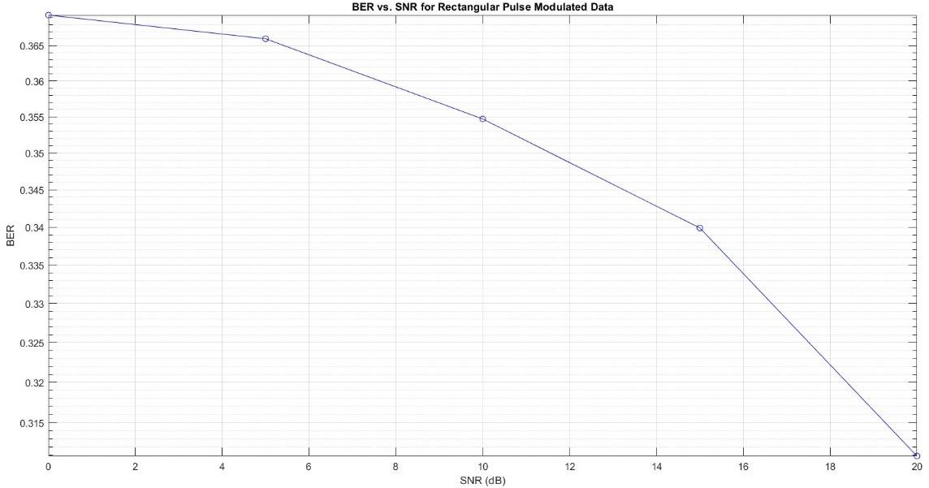

Exp 7

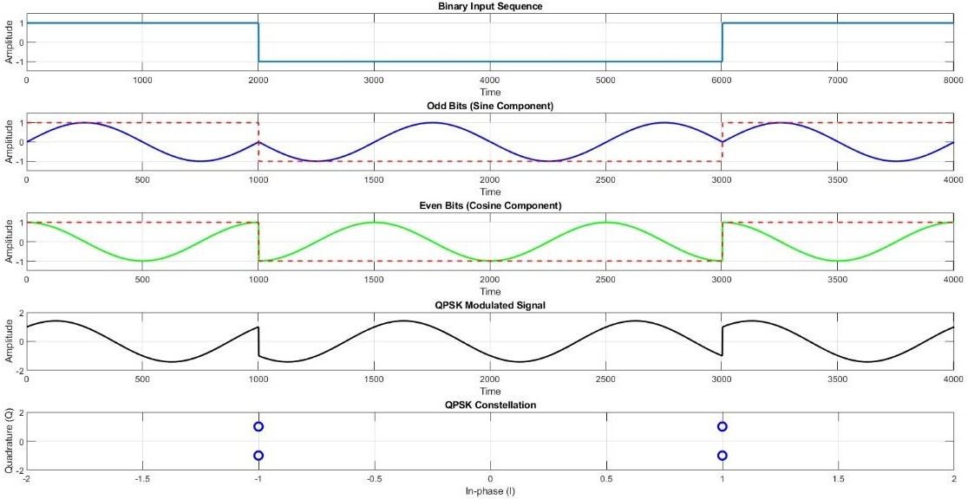

Exp8

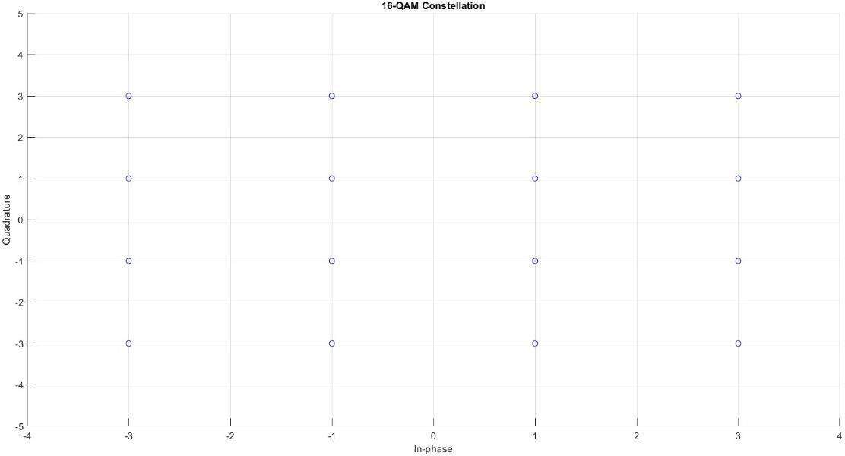

Exp 9

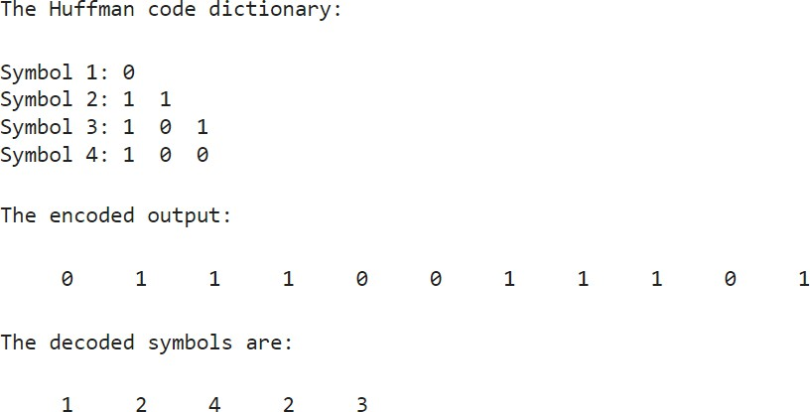

Exp10

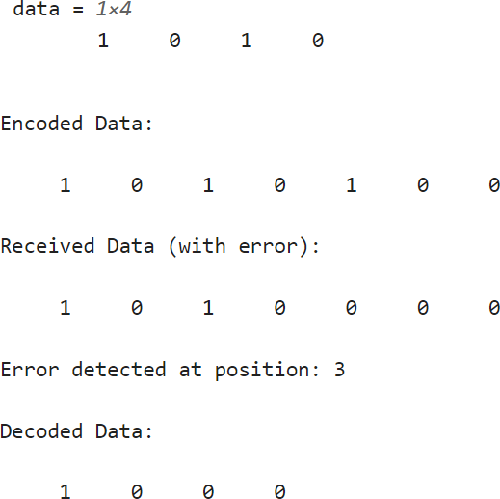

Exp 12

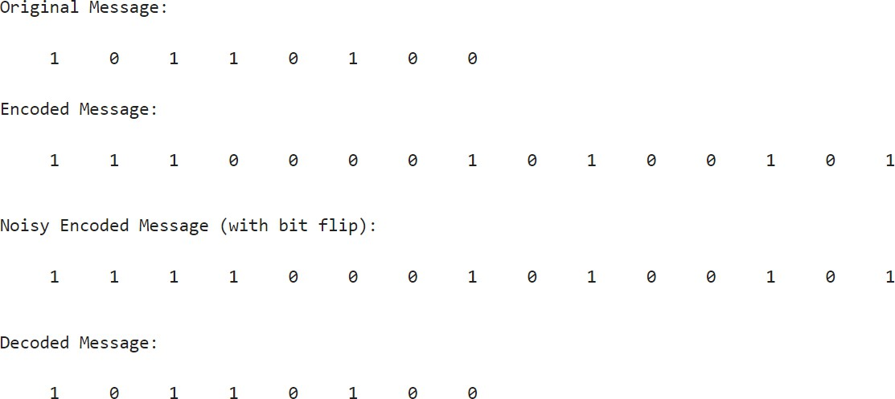

Exp5

